**How to Review PSAT scores (online and/or hard copy)**

Students can review their PSAT scores online and your school will receive paper score reports sometime around January 15th.  When students go to <https://studentscores.collegeboard.org>  they will see the screen below.

* Students click SIGN IN or SIGN UP depending on whether or not they already have a College Board account.  This is the same account used to access AP and SAT scores or register online for the SAT.
* **Important Note:  If a student does not see his/her PSAT score report after logging in, they should click the “Add Scores” button.  At this point the student MAY be prompted to enter their PSAT access code.  The student access codes are printed on the front of the hard copy score report.**

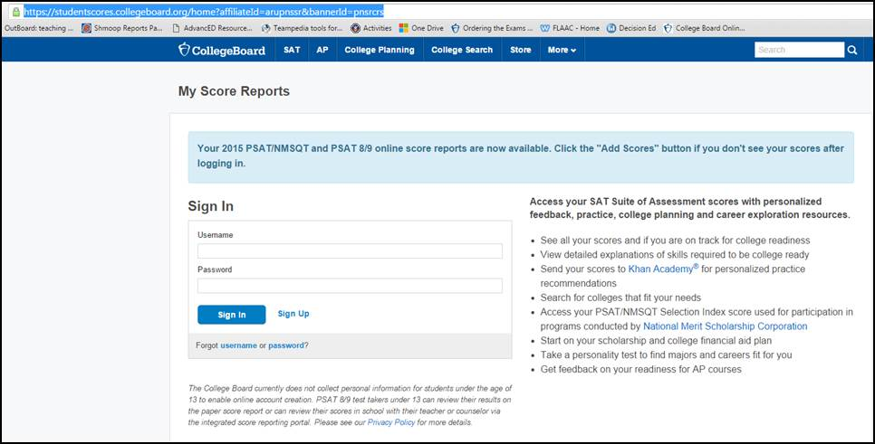

**How to Create a Khan Academy Account and Link to PSAT scores**

When students go to <https://Khanacademy.org/sat> they will see a blue and white screen that says Official SAT Practice and in the middle of the page is a button that says “Check it out now”.  When they click that button, they will be given the following screen and have to determine how to sign in.  If they choose to sign up with email, they will have to be able to access that email immediately, because Khan sends a link to the subscriber via email that has to be clicked to open the account.  There are additional directions below for linking PSAT scores to Khan.

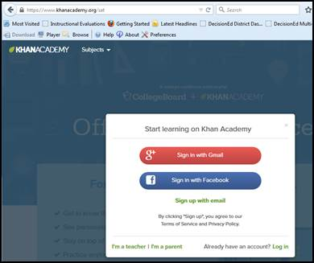

After creating a Khan account, when you sign in to <https://Khanacademy.org/sat> you will see a button that says “Practice now”.  After clicking the button you see the following screen.  On the left side of the screen the student clicks “Sign in to CollegeBoard.org” button and follows the prompts to link their PSAT results to Khan.  If a student did not take the PSAT then he/she can take the Reading & Writing diagnostics and the Math diagnostics in order to activate personalized SAT practice modules which I’ve shown below.

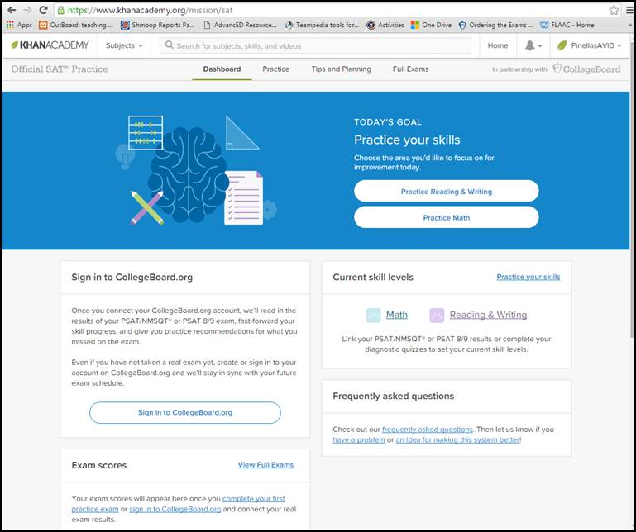

When clicking on the Practice Reading & Writing button on the screen above, I see all of the info in the next screen shot.  It provides 4 Diagnostic quizzes as well as additional links to practice and videos for Reading, Writing and language, Grammar and effective language use.  VERY user friendly ☺!!!

